a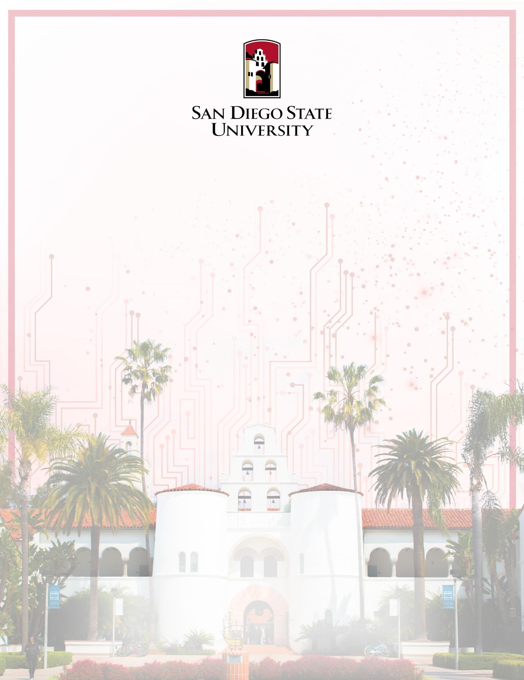

CompE-561 Windows Database and Web Programming

September 12th, 2021

Group Members, (RedID):

Dawod Rafoka (823-752-638)

James Bunnell (815-417-077)

Website Project – Front End

# Website title

The intended website title is **Pet Ball Dispenser – SDSU Senior Design Project**.

# Introduction

The website would be addressing the Senior Design project (Pet Ball Dispenser) our team had been working for the period of Spring 2021 – Fall 2021. Since for in this period, there is no Senior Design day where graduates present their work in the Montezuma hall, we are limited to presenting our project through a YouTube video. That, however, limits our capabilities to present multiple aspect of our project and a video lacks the interactive portion that website could offer.

Current Senior Design students, sponsors, professors, and future student would benefit from having an intuitive and interactive website for our Pet Ball Dispenser project. With more than 50 projects only from the Electrical and Computer Engineering department, it is substantial to stand out from the rest and give the audience a break from watching multiple videos one after another. Although our website will include a video section, it would not be the only presentation medium we will offer.

# Features

The website is intended to have a very minimal design to reflect the minimal look of the final project. Some of the features this website should include are:

* Dynamic resizing
* Minimal UI, font styles, and color schemes
* Smooth transitions and animations
* Responsive UI
* Navigation Bar

# Initial Components

* **Main Webpage (Home)**The main webpage will mainly consist of high quality pictures, taken with the website’s theme in mind, of the final project and its functionalities from different angles and aspects. The pictures may have settle side description explaining the design and features. This page could also include an embedded YouTube video demonstrating the project.
* **Mechanical Design**This tab will include technical drawings, 3D models images, and Actual pictures of the mechanical components along with their explanation.
* **Electrical Design**This will include the final rendering of the Printed Circuit Board (PCB), the actual PCB, and the schematics and parts used.
* **Firmware**This tab will include the Firmware integration, and the used code to run the microcontroller.
* **About Us**This will consist of the team’s mission along with the pictures, names, and short bio of each team member.
* **Questions?**This tab will include sufficient email addresses and a short form for any incoming questions and/or suggestions.